Ngā momo āhuatanga o te marae
He maha ngā mahinga ka tū ai i runga i tō mātou marae. He mea nui te manaakitanga ki a mātou. Ki te tū tētehi tangihanga koira te kaupapa mea tuatahi ahakoa he hui kē kei te haere. pērā i:

Te Tangihanga
Ngā momo huritau/rā whānau
Mārena
Hui tikanga Māori
Akoranga rāranga
Toi ataata
Hui reo Māori
Hui rangatahi
Pāti Kirihemete mō ngā tamariki
Hui Pūoro
Ohu whakatikatika marae
Christening
Hākari kaumātua
Hākari tōnamana hahau pōro

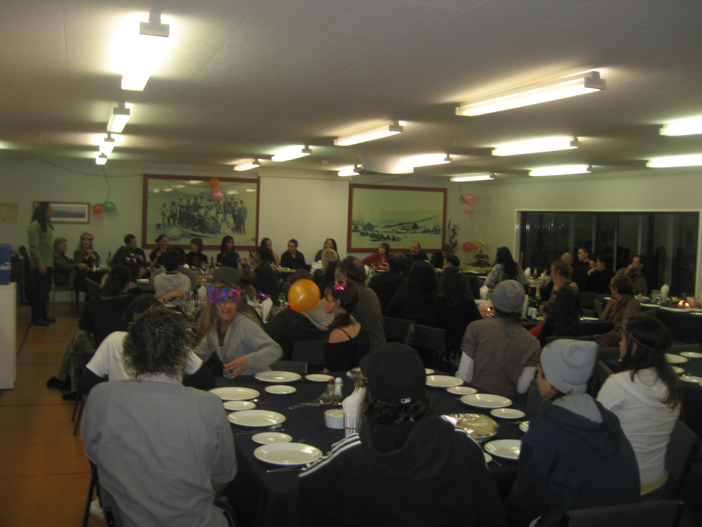 He rā whānau kei te haere

Ia tau, ia tau, tū ai ngā tini momo āhuatanga i runga i tō mātou marae. Whai ai mātou ngā tikanga/kawa o Tainui me ā mātou ake tikanga. He mea nui te manaakitanga ki a mātou. Ka pōwhirihia ngā waewae tapu.
Ahakoa te aha Ki te tū tētehi tangihanga koira te kaupapa tuatahi hei whakahaere mā mātou. Ahakoa he hui kē kei haere
Tangihanga Ngā momo huritau/rā whānau Mārena Hui tikanga Māori Akoranga rāranga Toi ataata Hui reo Māori Hui rangatahi Pāti Kirihemete mō ngā tamariki Hui Pūoro Ohu whakatikatika marae Christening Hākari kaumātua Hākari tōnamana hahau pōro

